How to combine images with OMERO

- Open your OMERO session and import your datasets containing the images (ie Tiff files).
Your Tiff files can contain the data for Channels, Z and Time.
- Select the dataset containing the images you want to combine, and in the OMERO menu, select the script button
- In the script menu, select “omero”, “util scripts”, “Combine Images”
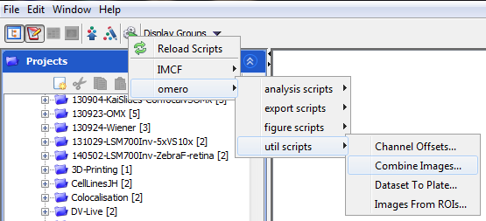
- Select “Dataset” for the data type, untick the “Auto Define Dimensions” box and select the “Manually Define Dimensions”
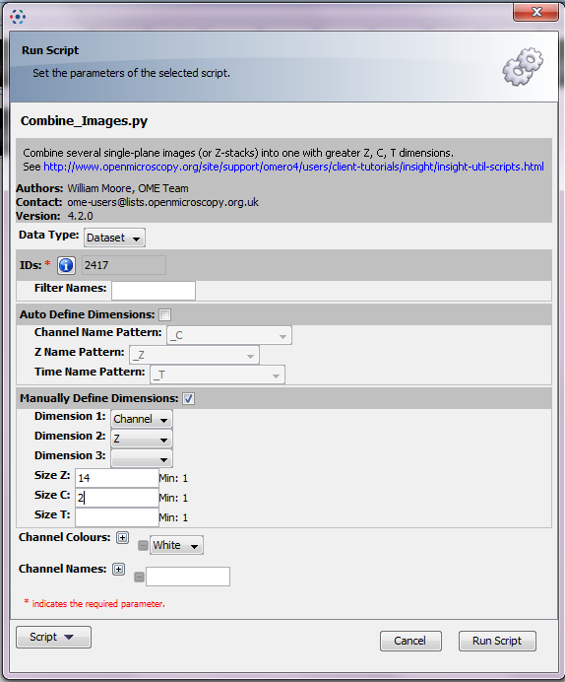
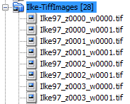
- For Dimension 1, select the parameter that is changing first in the name of the file. In our example, _w (channel) is changing first, then the z section (_z).
- For Dimension 2 and 3, select the 2nd and 3rd parameter to change in the naming (if required).
- Run the script. A “Combined Image will be created and added to your dataset.
Note: This cannot be batch processed so far.

