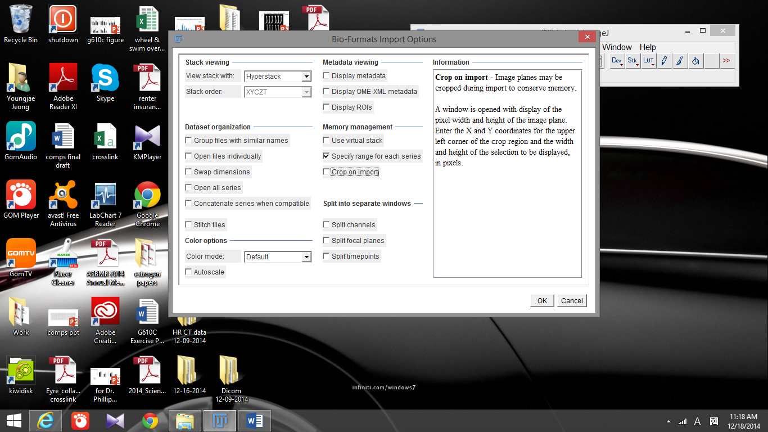

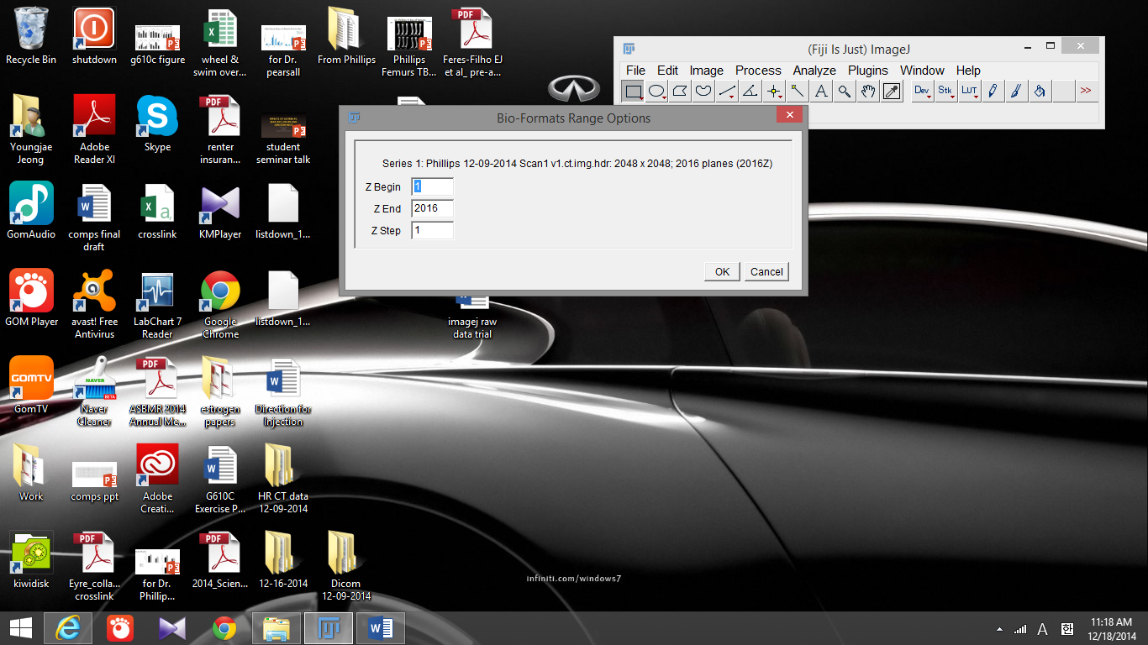

It let me pick the specific ranges of Z stacks. When I picked Z begin 1 to Z end 250-ish. It opens up fine.
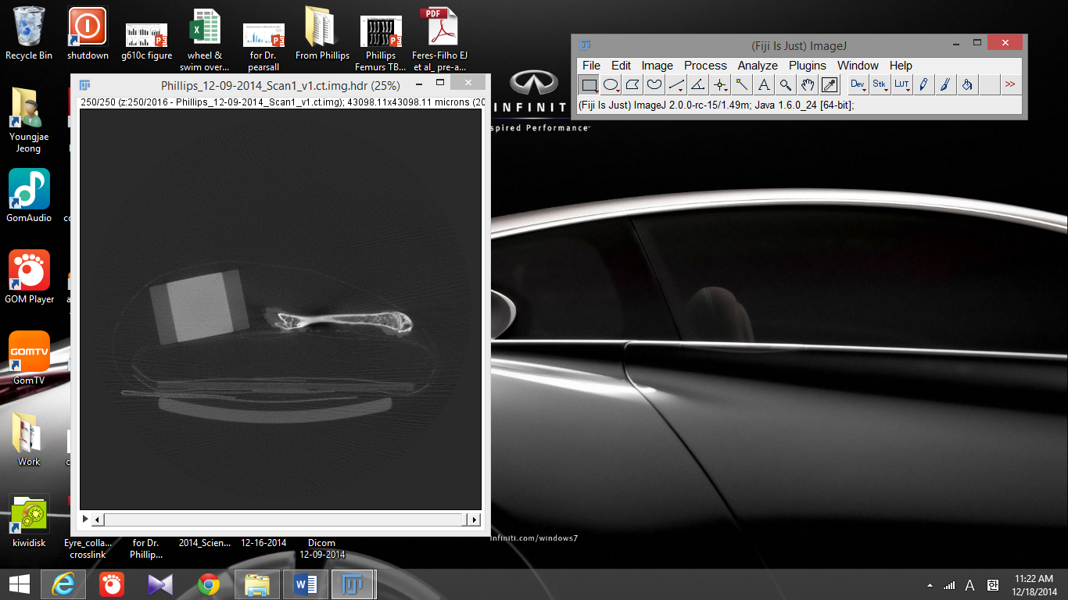
But once I pick up the range after 250…. It gives following error message
